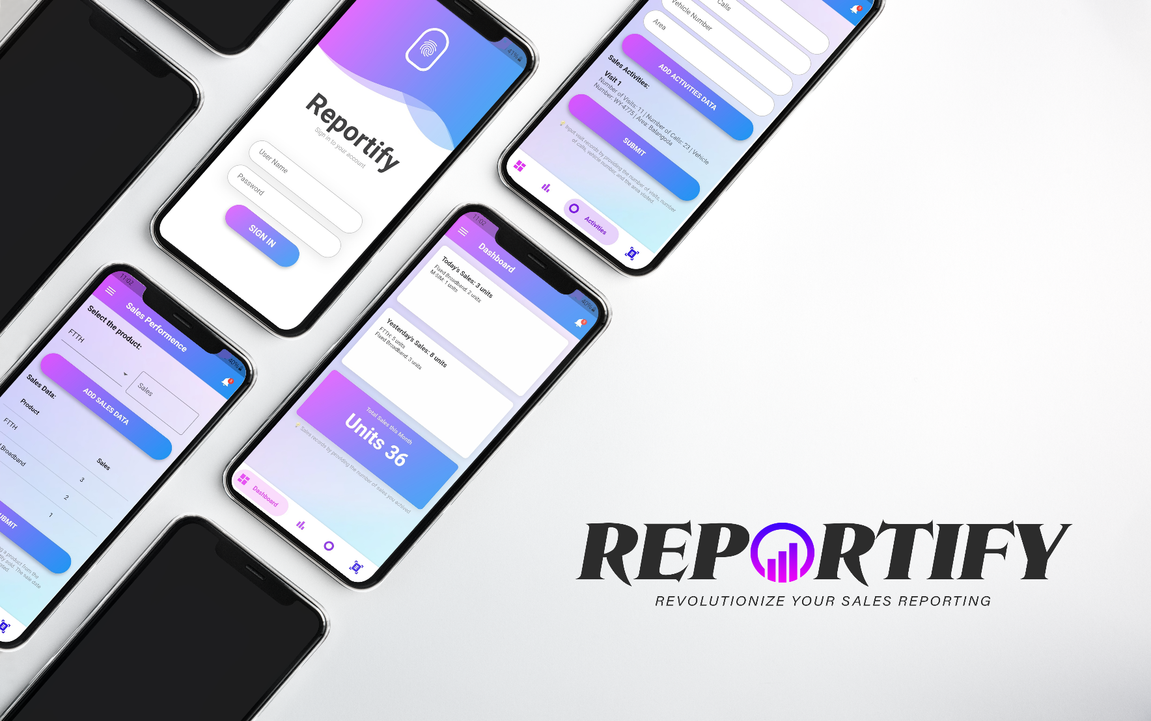

**CONTENTS**

INTRODUCTION 3

GETTING STARTED 4

2.1. Installation: 4

2.2. Login to account: 4

HOW TO USE 5

3.1. User 5

3.1.1 View Sales Performance 5

3.1.2. Input daily sales 5

3.1.3. Input daily sales Activity 6

3.2. Admin 7

3.2.1. List of Users 7

3.2.2. Add New User 7

3.2.3. View User Sales performance and activities 7

TROUBLESHOOTING 8

5.1. Gray Screen Error 8

UPDATES AND NEW FEATURES 9

CONCLUSION 10

# INTRODUCTION

Reportify is a powerful tool designed to simplify your sales management and increase sales productivity. The app lets you track daily sales, analyze performance, and report data to authorities.

Key Features and Benefits:

1. Entering daily sales data:

* Easily record your daily sales data, including date, product details and quantities sold.
* Streamline your data entry process and eliminate manual paperwork.

1. Monitoring sales activities:

* Gain insight into your sales performance with comprehensive activity tracking.
* Track sales trends, identify peak periods, and evaluate your progress over time.

1. Automatic Record Keeping:

* Reportify automatically saves and organizes your sales data, eliminating the need for manual record keeping.
* Enjoy a clutter-free and organized sales database at your fingertips.

1. User-friendly interface:

* Reportify offers an intuitive and user-friendly interface, making its features easy to navigate and use.
* Enjoy a seamless user experience that saves you time and effort.

Throughout this user manual, we'll guide you through Reportify various features, providing step-by-step instructions and tips for optimal use. Whether you are a beginner or an experienced user, this manual will serve as your resource to exploit the full potential of our application.

# GETTING STARTED

## 2.1. Installation:

Get and install Reportify from Authority.

Once the installation is complete, launch the app from your device's home screen.

## 2.2. Login to account:

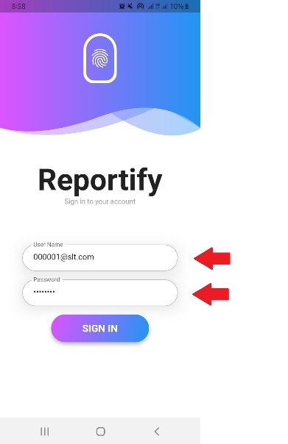Login using your email address and password provided to you by the authority.

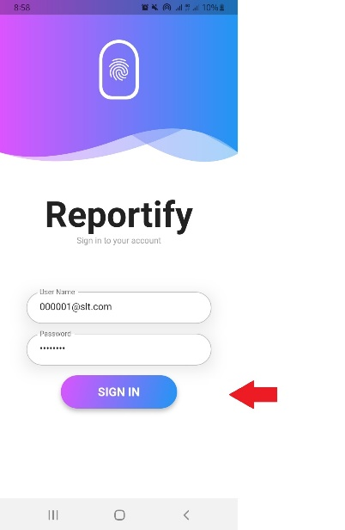Enter required credentials and tap on "Sign In" button.

**NOTE: If you have forgotten your pass****word, contact the administrator**

# HOW TO USE

## 3.1. User

### 3.1.1 View Sales Performance

How to View Daily Sales Forecast:

1. Access the "Dashboard" tab in the app.
2. 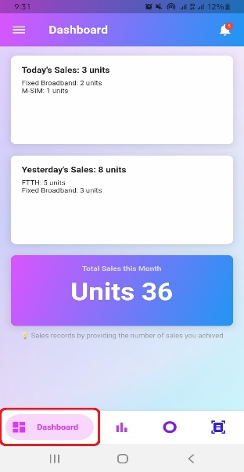View a summary of sales performance such as total sales and sales products for the day, yesterday and month.

### 3.1.2. Input daily sales

Step-by-step instructions for entering daily sales:

1. Access the “Sales Performance” tab of the app.
2. Enter relevant information such as product and quantity sold in the selected product section.
3. Repeat this step for each product sale.
4. Tap on the "Add Sales Data" button.
5. Repeat this step for each product sale.
6. You can see relevant information like the product you added and the quantity sold.
7. 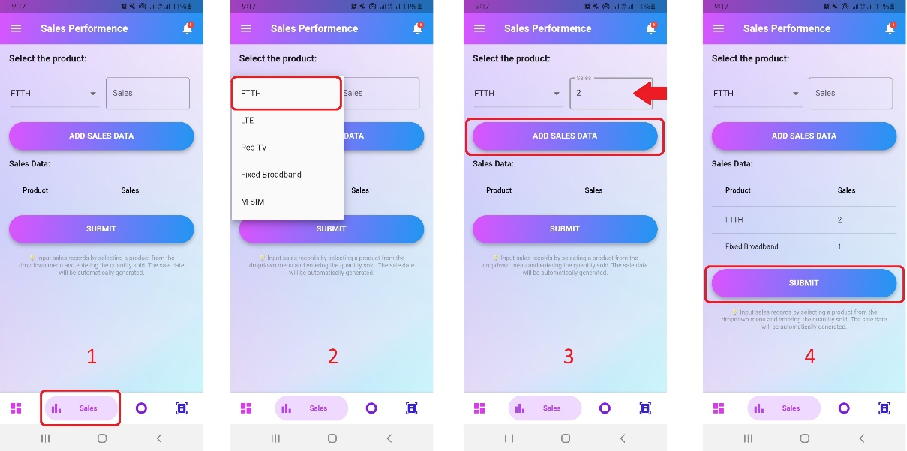Tap on "Submit" button to save the entry.

### 3.1.3. Input daily sales Activity

Step-by-step instructions for entering daily sales activities:

1. Visit the "Sales Activity" tab of the app.
2. Enter relevant information such as frequency of visits, number of calls, vehicle number and area you visited.
3. Tap on the "Add Activities Data" button.
4. Check the information you have entered here.
5. Tap on the "Submit" button to save the entry.

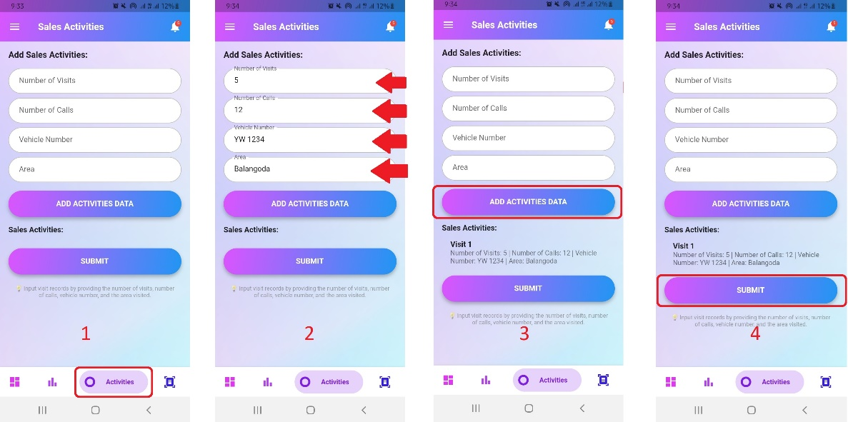

## 3.2. Admin

### 3.2.1. List of Users

See the user list of step-by-step instructions:

1. Access the "User Reports" tab of the application.
2. Select the category you want.

### 3.2.2. Add New User

Step-by-step instructions for adding a new user:

1. Access the "User Reports" tab of the application.
2. Click the bottom right button and access the "Add User" page
3. Enter the relevant information such as the name, email address, password and category of the user you wish to enter.
4. Tap on the "Add User" button.

### 3.2.3. View User Sales performance and activities

Step-by-step instructions for checking a user's sales performance and activities:

1. Access the "User Reports" tab of the application.
2. Select the category of the user.
3. Click on the name of the user you want to check.

# TROUBLESHOOTING

## 5.1. Gray Screen Error

If you are experiencing a gray screen error in your app, it may indicate a problem with the app's functionality or your device. Here are some troubleshooting steps you can try:

1. Restart the application:
   * Close the app completely by swiping away from the recent apps list or by force closing.
   * Relaunch the app and check if the gray screen error persists.
2. Clear the app cache:
   * Go to your device settings.
   * Navigate to Apps or Apps section.
   * Find and select your application from the list.
   * Tap on "Storage" or "Storage & Cache" (depending on your device).
   * Find the option to clear app cache and tap on it.
   * Restart the app and see if the gray screen error is resolved.
3. Restart your device:
   * Restarting your device can sometimes resolve temporary errors or conflicts.
   * Turn off your device completely, wait for a few seconds, then turn it back on.
   * Launch the app and check if the gray screen error still occurs.
4. Reinstall the app:
   * If none of the above steps work, you can try uninstalling and reinstalling the app.
   * Go to your device's settings and go to Apps or Apps section.
   * Find and select your application from the list.
   * Tap on the "Uninstall" button to remove the app from your device.
   * Visit the app store, download the latest version of the app and reinstall it.
   * Launch the app and check if the gray screen issue is resolved.

If the gray screen error persists after trying these troubleshooting steps, you may need to reach out to the app's developer for further assistance. He will be able to give you specific guidance and help you solve the problem.

# UPDATES AND NEW FEATURES

Recent updates to Reportify have focused on improving user experience and expanding functionality.

Here are some of the new features and improvements you can expect:

1. User Location Tracking:
   * A new feature has been introduced that allows Reportify to track the user's location using GPS technology.
2. PDF report generation:
   * You can now generate reports directly from Reportify in PDF format.
3. Performance improvements:
   * We have implemented various performance improvements to ensure a smooth and fast user experience.
   * These improvements optimize the app's functionality, making it more efficient and responsive.
4. Bug fixes and stability improvements:
   * We have addressed reported issues and fixed bugs to improve app stability and reliability.
   * Updates ensure Reportify runs smoothly, minimizes interruptions, and provides a consistent experience.

Remember to regularly check the App Store for updates to take advantage of new features and improvements as they become available.

# CONCLUSION

Finally, Reportify is a powerful tool for managing daily sales data and sales activities. With its user-friendly interface and intuitive features, it streamlines the process of recording sales information. The ability to track user location using GPS technology adds additional functionality and the option to generate reports in PDF format improves communication and collaboration. Regular updates ensure that the app remains optimized, stable and equipped with new features to meet your evolving needs. By following the user manual and taking full advantage of the app, you can maximize your sales performance and make data-driven decisions for success.